PRESS RELEASE
Contact: Mabel G. Schumacher, President
The Kennel Club of Fort Atkinson
c/o 848 Messmer Street
Fort Atkinson, WI 53538
Phone: 920-563-8454
Email: schu848@charter.net

November 18, 2010

FOR IMMEDIATE RELEASE

The Kennel Club of Fort Atkinson, Inc. Provides
Dog Watering Fountain on the Glacial Bike Trail

The Kennel Club of Fort Atkinson (KCFA) received a $3,300 matching fund grant from the Fort Community Foundation to install a dog-watering fountain on the Glacial Bike Trail. The fountain site—to be known as the Marie Heinke Rainbow Bridge Memorial—will honor the memory of former KCFA member Marie Heinke, who loved dogs and cared deeply about their well being. Heinke lost a long-fought battle with kidney cancer in 2005.
KCFA has worked with the Fort Atkinson Park and Recreation Department and the City of Fort Atkinson to locate the memorial fountain on the Bike Trail near the white barn (at Eighth Street). Components of the new rest stop on the Trail are the canine/human fountain, a bench donated by the Northey family in honor of their parents, a puppy statue, and a picnic table donated by the City. The memorial project has been completed and KCFA is planning a dedication at the fountain site with a reception to follow at the KCFA training site to celebrate the occasion.
Other activities offered by KCFA include training classes in Puppy Kindergarten, Basic Manners, Advanced Obedience, and Conformation; Canine Good Citizen certification; therapy dog certification; Reading with Dogs; therapy dog visits; Community Dog Walks, Photos with Santa; and a variety of other community activities.
The KCFA training site is located at 710 Oak Street, Fort Atkinson (formerly the Thomas Industries building). Visit KCFA’s web site at www.kcfadogs.org.
--more--

The mission of The Kennel Club of Fort Atkinson, Inc. is to improve the quality of life for dogs, to promote responsible dog ownership for the community, to foster the human-animal bond by providing training and activities. KCFA values activities that foster the human-canine bond, training opportunities for owners and handlers of dogs, competitive activities in conformation and performance, and sportsmanship in all dog-related activities

Pictures follow:

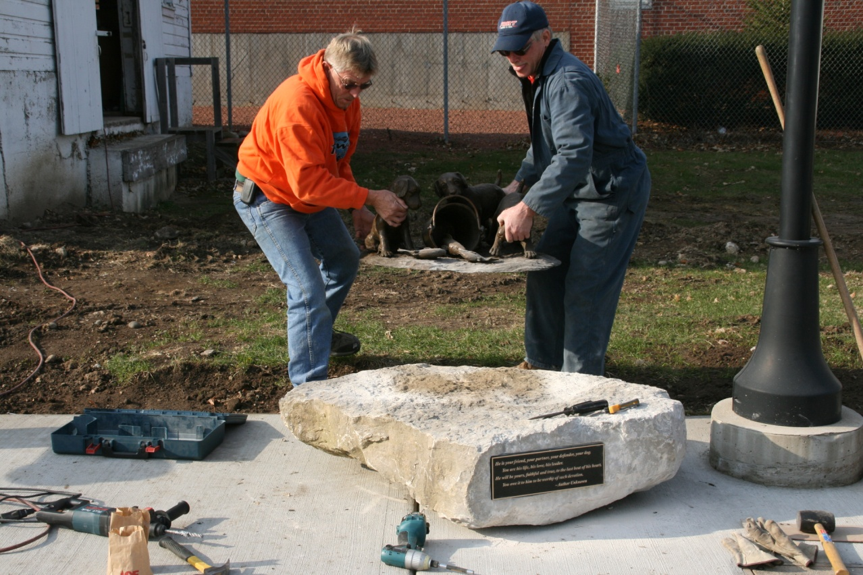

Puppy Sculpture Being Installed

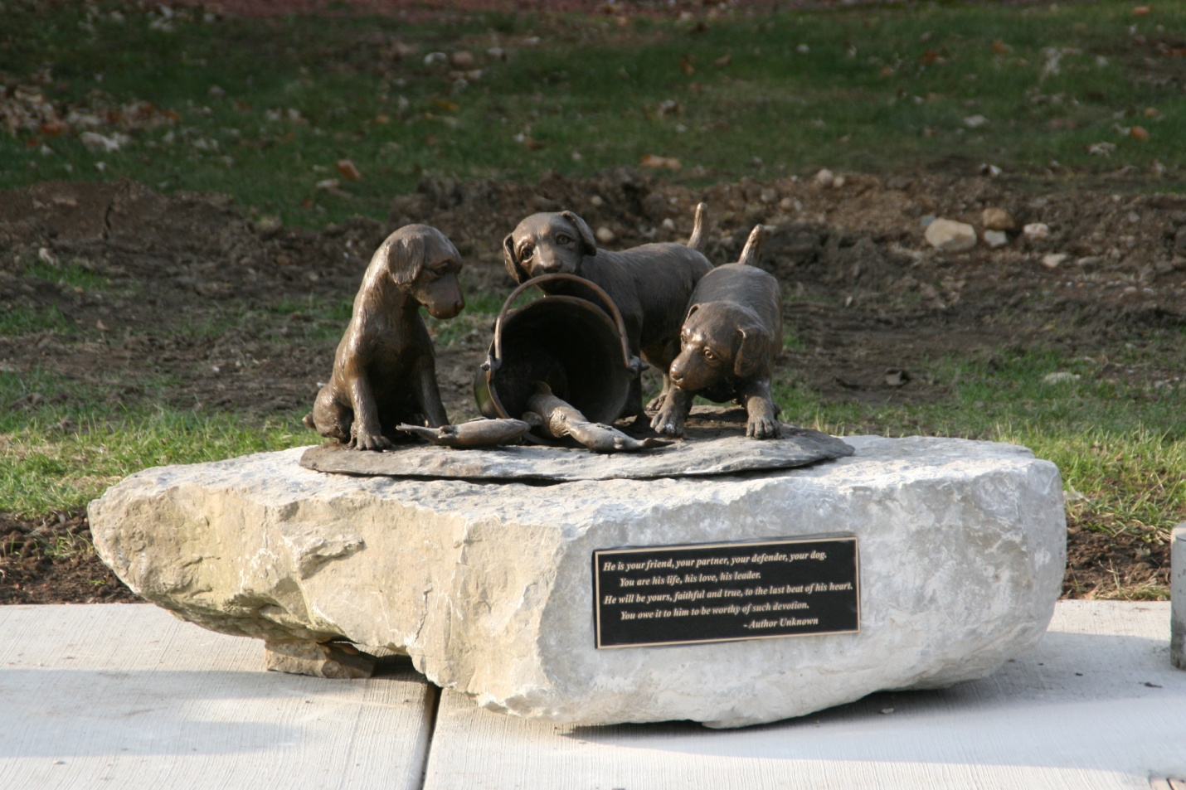

Puppy Sculpture Quotation
He is your friend, your partner, your defender, your dog.
You are his life, his love, his leader.
He will be yours, faithful and true, to the last beat of his heart.
You owe it to him to be worthy of such devotion.
-- Author unknown

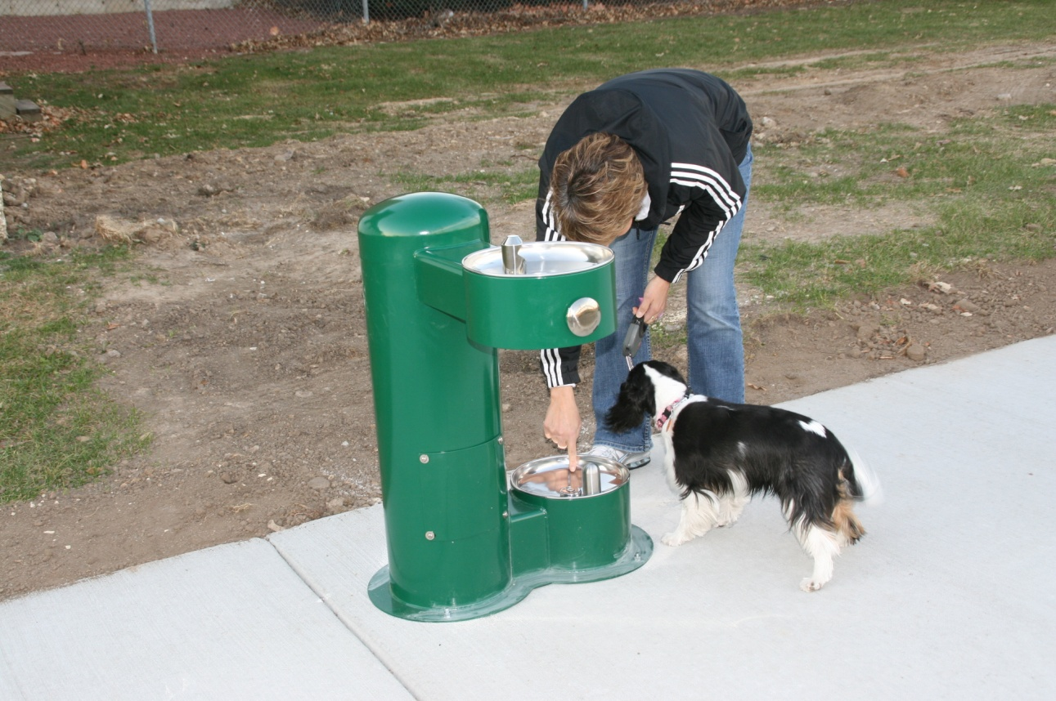
Dog and human fountain – first visitor

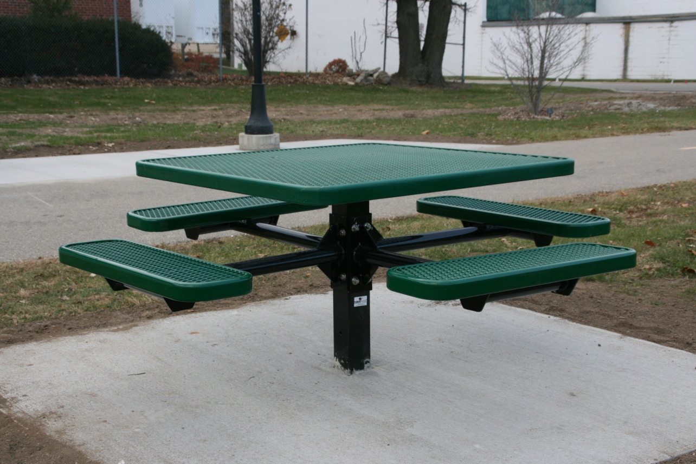
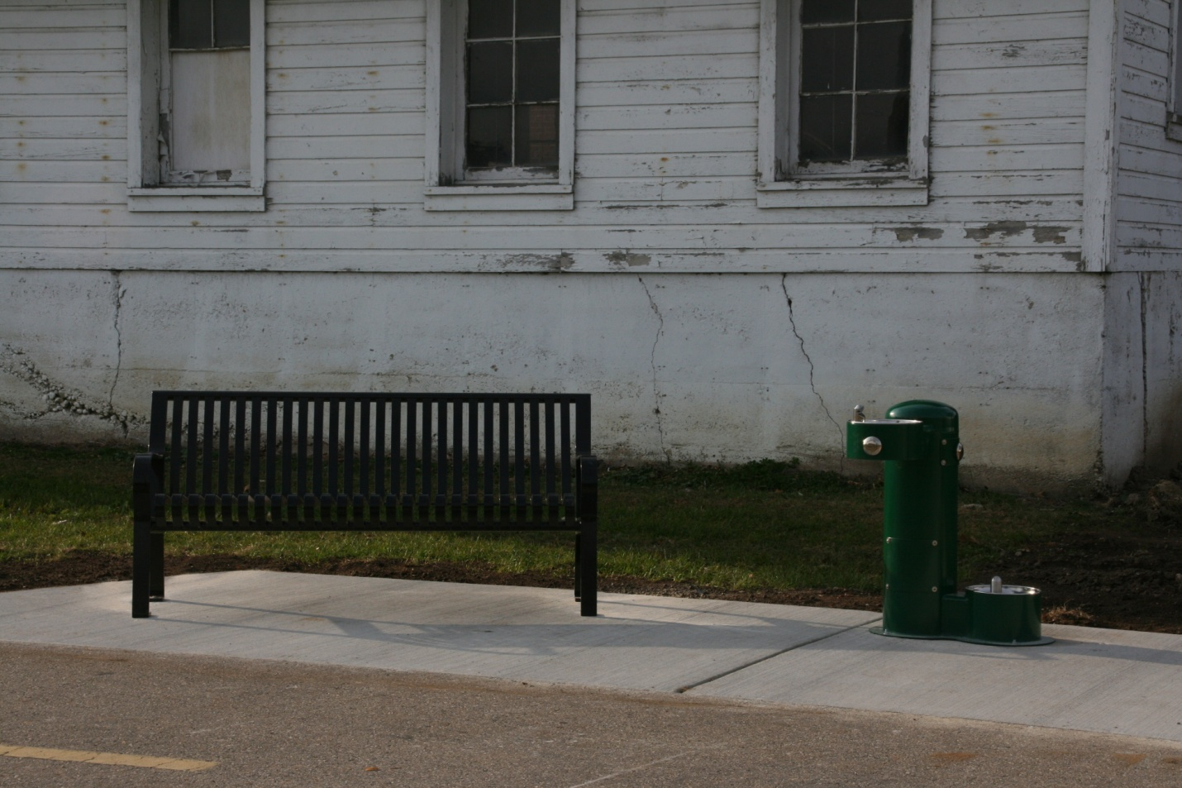
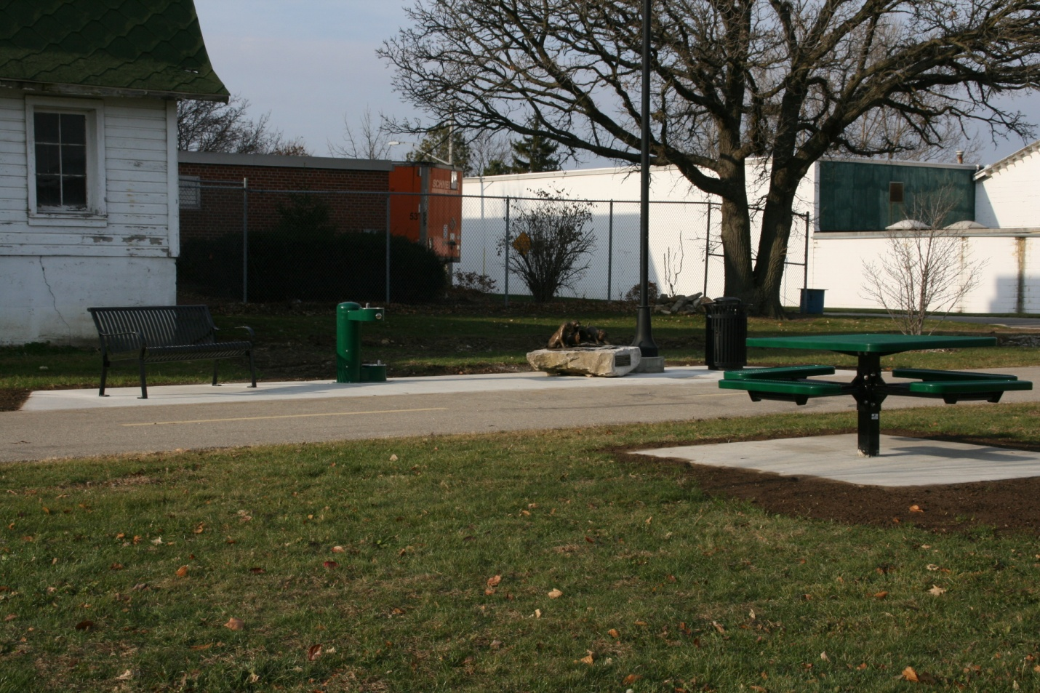
Additional information: Bench donated by the family of Harold and Shirley Northey
The family of Harold and Shirley Northey wanted to honor their parents by donating a bench in their memory.

The white barn has great significance to the Northey family. Harold worked for Jones Farm for over 30 years, and for 10 years of that time he served as a night watchman. Harold would often take his evening break standing outside the white barn, gazing at the night sky and enjoying the beauty of what is now Jones Park.

The Northey children remember the delightful times when they were able to join their father during his lunch break and share time together.

As active members of the Fort Bike Club, Harold and Shirley also enjoyed the Glacial Bike Trail, which makes the location of the bench even more special.

